A PROJECT REPORT

on

“Online Parking Booking System”

Submitted to

KIIT Deemed to be University

In Partial Fulfilment of the Requirement for the Award of

BACHELOR’S DEGREE IN

INFORMATION TECHNOLOGY

BY

Aniket Kumar Mishra
Ujjwal Singh
Abdul Wahid Aadil
Ankit Dev

2029187
2029193
2029194
2029195

UNDER THE GUIDANCE OF

- Neha



SCHOOL OF COMPUTER ENGINEERING

KALINGA INSTITUTE OF INDUSTRIAL TECHNOLOGY

BHUBANESWAR, ODISHA - 751024

May 2020

A PROJECT REPORT

on

“Online Parking Booking System”

Submitted to

KIIT Deemed to be University

In Partial Fulfilment of the Requirement for the Award of

BACHELOR’S DEGREE IN INFORMATION TECHNOLOGY

BY

Aniket Kumar Mishra
Ujjwal Singh
Abdul Wahid Aadil
Ankit Dev

2029187
2029193
2029194
2029195

UNDER THE GUIDANCE OF

B. Neha

SCHOOL OF COMPUTER ENGINEERING

KALINGA INSTITUTE OF INDUSTRIAL TECHNOLOGY

BHUBANESWAE, ODISHA -751024

May 2022

KIIT Deemed to be University

School of Computer Engineering
Bhubaneswar, ODISHA 751024

CERTIFICATE

This is certify that the project entitled

“NAME OF PROJECT“

submitted by

Aniket Kumar Mishra
Ujjwal Singh
Abdul Wahid Aadil
Ankit Dev

2029187
2029193
2029194
2029195

is a record of bonafide work carried out by them, in the partial fulfilment of the requirement for the award of Degree of Bachelor of Engineering (Computer Sci-ence & Engineering OR Information Technology) at KIIT Deemed to be university, Bhubaneswar. This work is done during year 2022-2023, under our guidance.

Date: / /

(Guide Name)
Project Guide

Acknowledgements

We are profoundly grateful to B. Neha of Affiliation for her expert guidance and continuous encouragement throughout to see that this project rights its target since its commencement to its completion. .....................

Aniket Kumar Mishra(2029187)
Ujjwal Singh(2029193)
Abdul Wahid Aadil(2029194)
Ankit Dev(2029195)

ABSTRACT

In cities where the population is at its highest and the roads are clogged with cars and heavy traffic. Finding a parking space for our car becomes a challenge in such a densely populated area. We developed a concept where consumers could log in to our web application and locate the optimal parking space. Java and MySQL were used in the development of our project's online parking booking system. The users save time and gasoline in this way. The user may quickly check the web application for parking availability and proceed to the location without losing any time. Users may examine the fee information for parking their cars. The user will be allowed to park the automobiles in this project in accordance with It will be quite simple for the administrator who oversees all of these parking to handle both their time slot and these matters. The parking authority can simply and effectively manage their parking places using such a system.

Keywords: Parking management system, Online parking booking,
Smart parking, Vehicle detection & Parking availability

Contents

1 | Introduction |  |  | 1
2 | Basic Concepts/ Literature Review |  |  | 2
 | 2.1 | Tools and Techniques |  | 2
 | 2.2 | Literature Review |  | 3
3 | Problem Statement / Requirement Specifications |  |  | 4
 | 3.1 | Project Planning........................... |  | 4
 | 3.2 | Project Analysis (SRS)................. |  | 5
 | 3.3 | System Design ………………….. |  | 6
 |  | 3.3.1 | Design Constraints …… | 6
 |  | 3.3.2 | System Architecture (UML) / Block Diagram … | 7
4 | Implementation |  |  | 9
 | 4.1 | Methodology / Proposal ........................... |  | 9
 | 4.2 | Testing / Verification Plan ……………. |  | 10
 | 4.3 | Result Analysis / Screenshots …………. |  | 10
 | 4.4 | Quality Assurance …………………….. |  | 14
5 | Standard Adopted |  |  | 15
 | 5.1 | Design Standards . . . . . . . . . . . . . . . |  | 15
 | 5.2 | Coding Standards . . . . . . . . . . . . . . |  | 16
 | 5.3 | Testing Standards . . . . . . . . . . . . . . . |  | 17
6 | Conclusion and Future Scope |  |  | 19
 | 6.1 | Conclusion ……………………….. |  | 19
 | 6.2 | Future Scope ………………………. |  | 19
References |  |  |  | 20
Individual Contribution |  |  |  | 21
Plagiarism Report |  |  |  | 25

Online car parking system

Chapter 1

Introduction

Finding a free parking spot for a car has become a mind-numbing task in the twenty-first century, especially for those who commute to work in the morning or are going about their daily routines. These people find it extremely tough and challenging to secure a parking spot for their automobiles. Additionally, parking spaces are never user-friendly and offer no logical information regarding the spot's availability unless the user manually visits it. Everybody encounters problems of this nature on a regular basis because there is a high level of uncertainty and there aren't many viable solutions to the problem that could save the users' time or maintain their positive and carefree mental state. In our increasingly crowded cities and areas.As traffic grows, it gets more and more difficult to find a parking spot. Drivers waste their valuable time, fuel, and are more likely to cause accidents by turning around and around in search of parking places. We can observe that the parking mechanism in the current setup needs some monitoring and isn't entirely automated. The driver must ensure that the vehicle is parked in a location that won't interfere with other people's convenience. Finding a location to park is typically the biggest challenge, and attempting to find a spot increases stress for the person operating the vehicle. Additionally, the implementation of the parking procedure is structurally dependent on the relative analysis of the data. Nowadays,, finding a parking space is really difficult in our crowded environment. The user does not receive a reserved parking space inside the area under the existing parking arrangement. We want to offer a solution to this issue because parking is often a tedious and time-consuming task.

School of Computer Engineering, KIIT, BBSR 1

Online Car Parking Booking System

Chapter 2

Basic Concepts/ Literature Review

The project aims to develop a web-based platform where users can reserve parking spaces online. This system provides a convenient solution for users to find and book parking spots, saving time and effort. The basic concepts about the related tools and techniques used in this project. and the literature review For research work are as follows :

2.1 Basic concepts about the related tools and techniques :

- Web Application Development : The project uses Java as the programming language and web application development methodologies. Due to its scalability, security features, and platform portability, Java is a popular and frequently used language for web development.
- MySQL Database : To store and manage parking-related data such user identity, parking availability, price information, and time slots, the project uses MySQL, a relational database management system. The strong and popular database system MySQL is renowned for its dependability and efficiency.
- User Interface Design : The project's main goal is to provide a web application interface that is simple and easy to use. To guarantee a favourable user experience, user interface design elements including usability, accessibility, and responsiveness are crucial.
- Parking Availability Management : The system has a function that shows users the availability of parking in real-time. For this capability to deliver precise and current information on parking places, effective data management and synchronisation are required.
- Pricing and Payment Integration : The project integrates parking spot cost information and offers users a safe online payment interface. To enable simple and secure online payments, this entails the implementation of payment gateways or other third-party services.
- System Testing : A critical component of software development is testing. To guarantee the functionality, dependability, and usability of the system, the project incorporates a variety of testing methods, including unit testing, integration testing, and acceptance testing.

2.2 Literature Review :

The review of the literature gives a summary of numerous studies on parking management systems. The articles under evaluation concentrate on a variety of parking system-related topics, such as RF signal propagation prediction, intelligent parking guidance, automated parking systems, parking space recognition using convolutional neural networks (CNNs), and IoT-based parking systems.

In order to increase the effectiveness of wireless sensor network (WSN) deployment in smart city, intelligent transportation, and parking lot systems, the first study suggests empirical route loss models that are particularly created for indoor and outdoor parking lots.
The design of an intelligent parking guidance system for Metro Manila retail centres is covered in the second paper. The research examines current parking options and discusses problems and challenges experienced by users. It helps to improve the standard of parking facilities by advancing the development of an intelligent parking assistance system that guides automobiles to available parking spots.

The third article offers an intelligent parking system (IPS) with attributes including notification of car damage and parking recommendations. The IPS makes use of autonomous driving while assisting drivers with parking by including visual and audible cues as well as a system for notifying them of vehicle damage.

The topic of the fourth article is computer vision and CNN-based automatic parking spot recognition. The technology accurately predicts occupancy while categorising parking spots in real-time. It aids in the effective management of parking spaces.

In order to solve traffic congestion and parking space availability, the fifth article suggests an IoT-based e-parking system for smart cities. The system uses IoT technology to manage parking metres efficiently and automatically collect fees.

Overall, by addressing a variety of issues and enhancing the parking experience, these studies help to design effective and user-friendly parking management systems.

School of Computer Engineering, KIIT, BBSR 3

Online Car Parking Booking System

Chapter 3

Problem Statement / Requirement Specifications

Finding parking spaces becomes difficult in cities with high traffic densities. This problem is addressed by our Java-based online parking booking system, which enables users to use our web application and quickly find available parking spaces. Users can save time and gasoline this way. They may reserve slots depending on their desired time and examine information about cost and parking availability. For administrators, the solution makes parking management simpler and boosts overall effectiveness.

3.1 Project Planning

List of features to be developed :-

- User Login
- Admin Login
- Parking Availability
- Automatic Cost calculation

User login:
Users must register with the system by entering their name, birthdate, email address, gender, phone number, address, and password. Users who successfully register can log in with their credentials. Users may browse parking rates, reserve parking spaces, and access their booking information after logging in.

Admin Login:
An administrator who has access to the system can log in and manage its many features. The administrator may see user information, reservations, and parking fees. They can obtain detailed booking information, including related prices, and they have the power to change parking fees.

Parking availability
By clicking on the slots, users may verify the availability of parking spots. Yellow marks indicate reserved spots, whereas regular colour displays available spaces. Users may reserve parking spots online for the specific date and time they want, guaranteeing they get a spot that works for them. A user cannot choose a space that has already been reserved by another user.

Automatic cost calculation:
Based on the user's specified booking time, the system automatically determines the total cost of parking. There is a "Book Parking" option inside the user login. Users enter the day, time, and length of their parking stay here. Instead of requiring the user to manually compute the hours, the system calculates them automatically and presents the total.

3.2 Project Analysis

Existing System:

It might be difficult for cars to locate parking in densely populated, heavily congested metropolitan areas. This frequently results in careless parking and traffic infractions. The manual parking management method in use today is ineffective and does not take parking timing slots into consideration or efficiently use available space.

Disadvantages of Existing System:

- Manual Works.
- Everything is paper work.
- User not able to select the desired location, date or time.
- More manual hours are needed for checking the spaces available.
- Tedious to manage historical data on which date and time the booking has been done

Proposed System:

An online parking reservation system that makes it easier to reserve parking spots is the suggested proposal. By offering a web-based reservation system, it handles the time-consuming process of locating parking in business locations. Users may browse various parking lots, check for available spots, and reserve a place for a particular time period. The restricted area is designated as yellow and tagged with a time limit, making sure no one else may use it. For convenience, there are online payment alternatives available. The system may be used by businesses to automate their employee parking, by institutions and organisations to automate their parking system, and by the general public to park in public spaces like malls and subway stations.

Advantages of Proposed System:

- Users can learn about parking areas for particular locations.
- It saves user time in search of parking space available in such a long parking area.
- The system provides a graphical view of the parking spaces.
- User can pay online on the spot and confirm their space.
- It excludes the need of human efforts for managing parking spaces.
- Cost-effective.
- The proposed system provides better information for the users of this system easily they can see the available slots and book from anywhere without facing any difficulty.
- The proposed system does not require any physical presence during booking.
- The proposed system has good authentication so only authorized person can able to login and book it.

3.3 System Design

3.3.1 Design Constraints

Hardware Requirements:

- System : Intet Core i7 10th Gen
- Hard Disk : 512 GB.
- Ram : 16 GB

Software Requirements:

- Web Tech : HTML, CSS
- Coding Language : JAVA.
- Tool : Netbeans 8.2
- Database : MYSQL

3.3.2 System Architecture OR Block Diagram

System Architecture:

I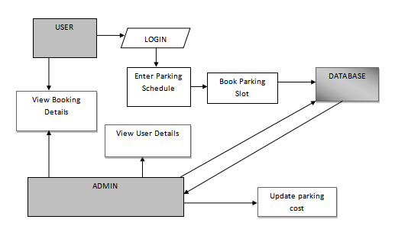

Admin:

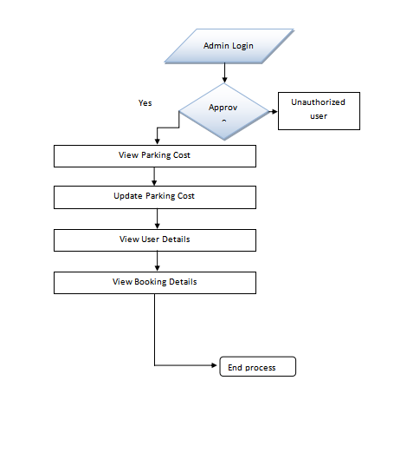

Users:

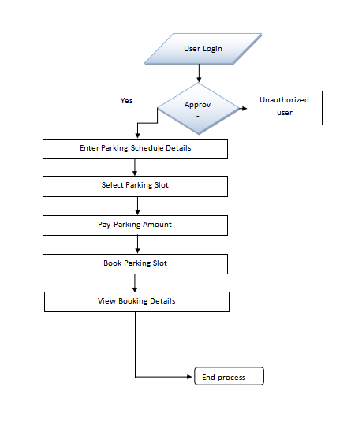

School of Computer Engineering, KIIT, BBSR 8

Online Car Parking Booking System

Chapter 4

Implementation

In this section, present the implementation done by you during the project development.

4.1 Methodology OR Proposal
This sub-section contain the methods you have used to complete the project, or some algorithms used and developed for your project work. Details about the steps adopted for competing the project work.

- The steps typically involved in completing the project are:
- Requirements gathering: Understand about the goals of the project and get input from the stakeholders.
- System design: Define the user interface design, database schema, and system architecture.
- Database design: Design the database schema by applying normalisation techniques.
- Front-end development: Implement the user interface with CSS and HTML.
- Back-end development: Develop the server-side logic using Java programming languages.
- Database implementation: Set up the MySQL database and create necessary tables and relationships.
- Integration with external services: Integrate the application with payment gateways, mapping services, etc.
- Testing and quality assurance: Conduct thorough testing at different levels and develop comprehensive test cases.
- Deployment and hosting: Deploy the application on a web server or cloud platform.
- User acceptance testing: Collect user feedback and check the application against the specifications.
- Documentation: Create technical guides, system architecture documents, and user manuals.
- Maintenance and support: Provide ongoing maintenance, bug fixes, and feature enhancements.

Depending on the objectives and characteristics of the project, particular techniques and algorithms could be employed, such as search algorithms for locating the best parking spots or scheduling algorithms for controlling time slots and bookings.

4.2 Testing OR Verification Plan

User Name | User ID | Parking Date | Start Time | End Time | Slot Name | Booking Time | Parking Cost
Abdul | 1 | 2023-03-22 | 12:00:00 | 14:00:00 | Slot 1 | 2023-05-04  18:48:00 | 40
Ankit Dev | 2 | 2023-06-04 | 06:00:00 | 12:00:00 | Slot 13 | 2023-05-04  18:52:00 | 120
Ankit Dev | 2 | 2023-05-04 | 12:00:00 | 13:00:00 | Slot 2 | 2023-05-04  23:45:56 | 20

4.3 Screenshots

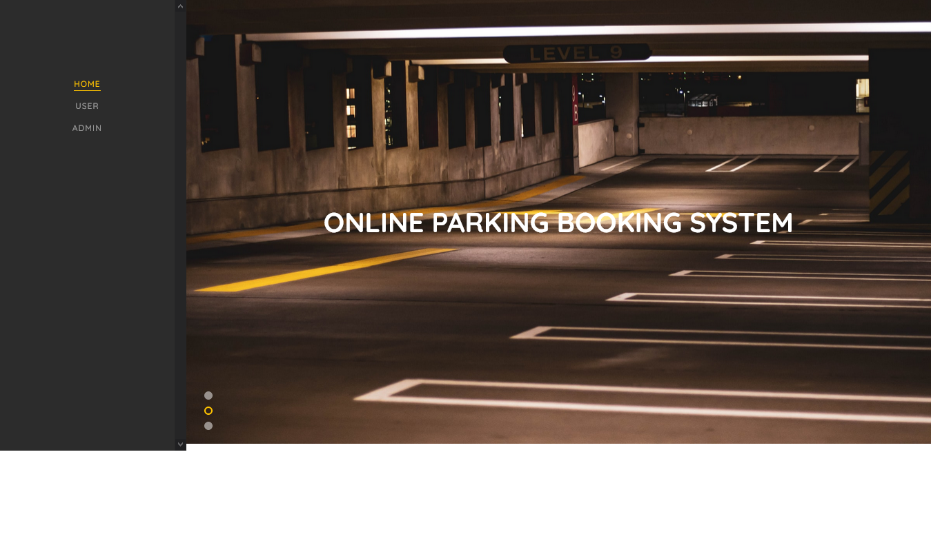

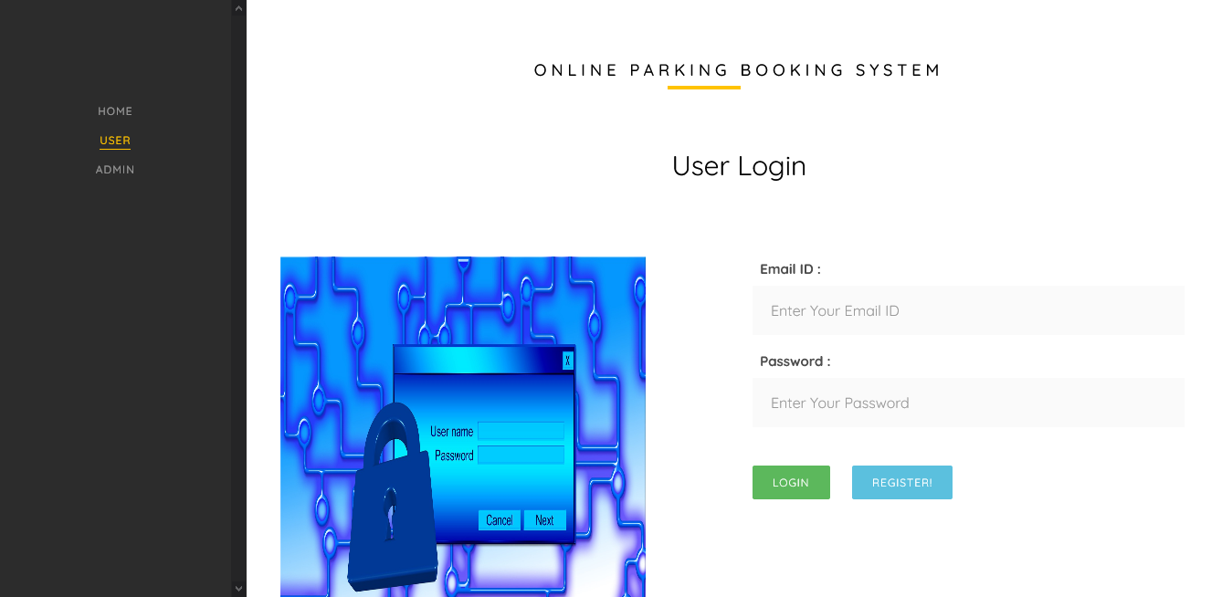

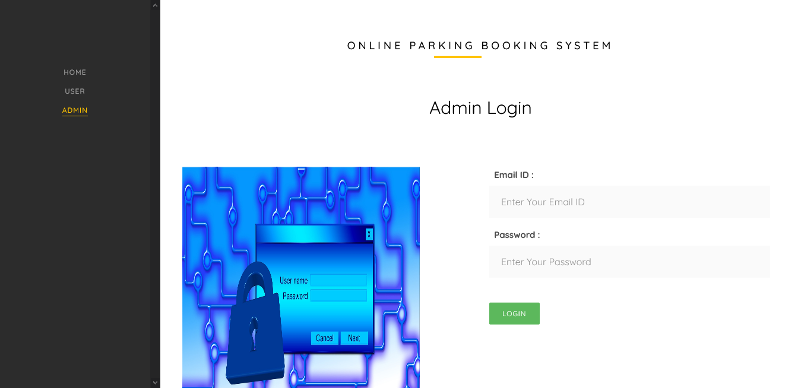
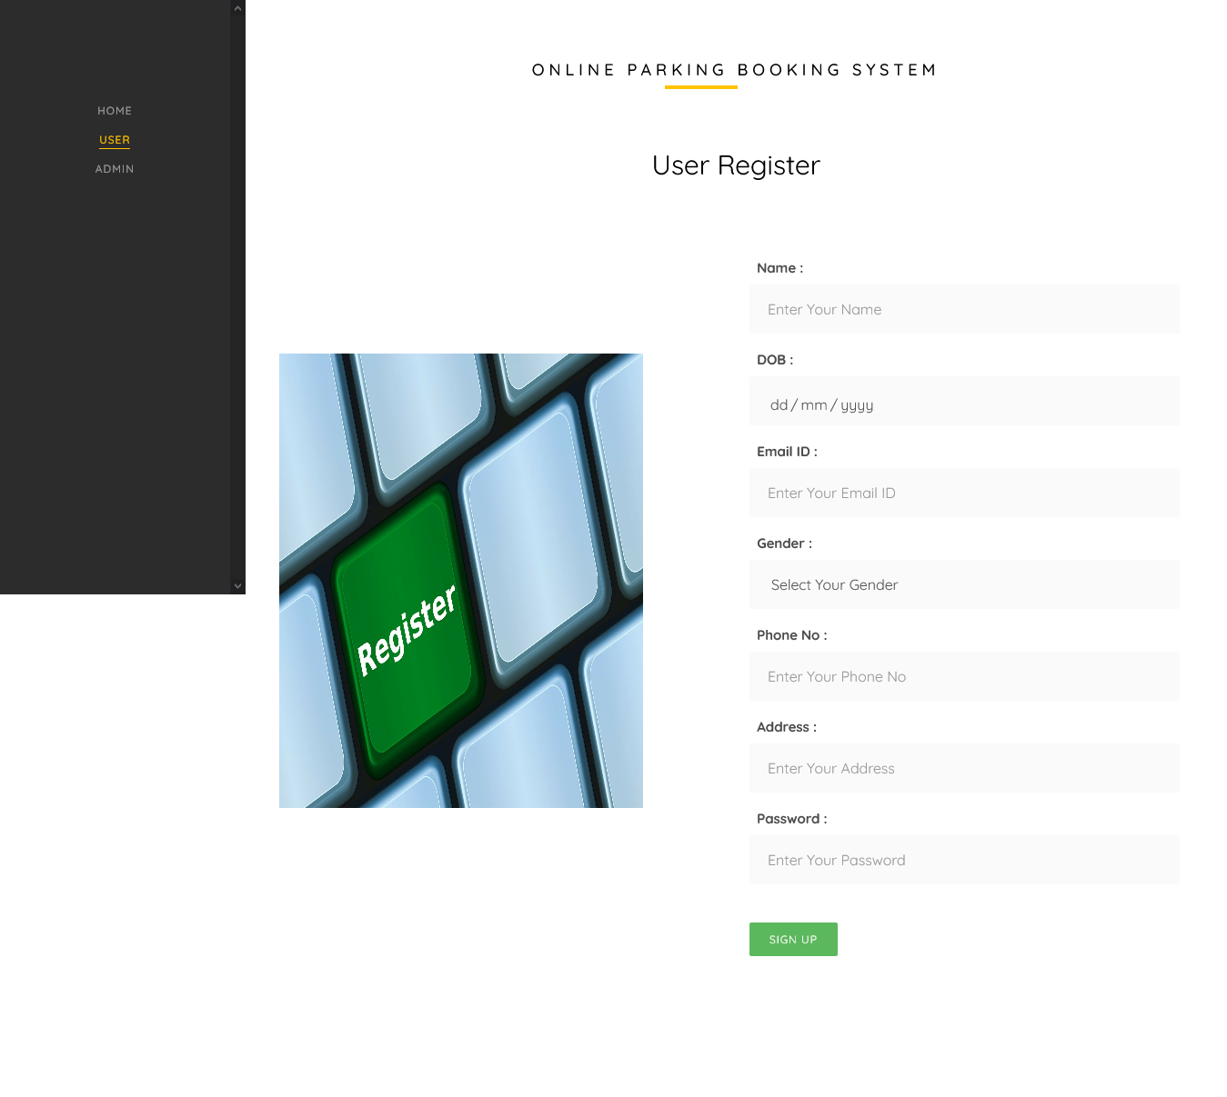
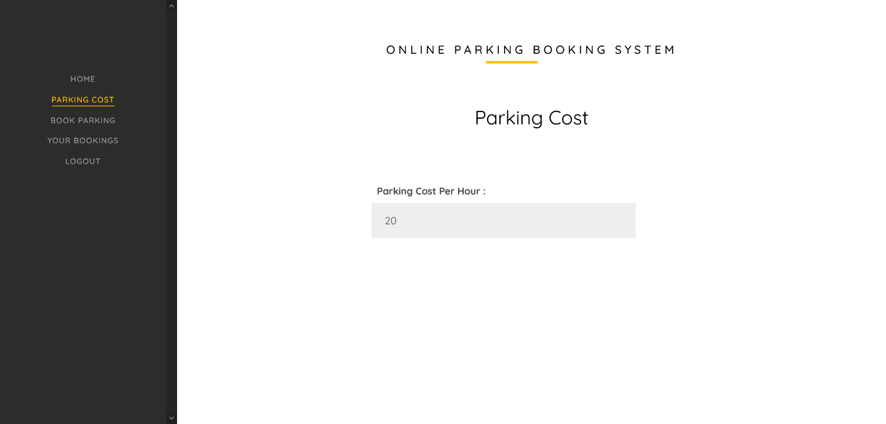

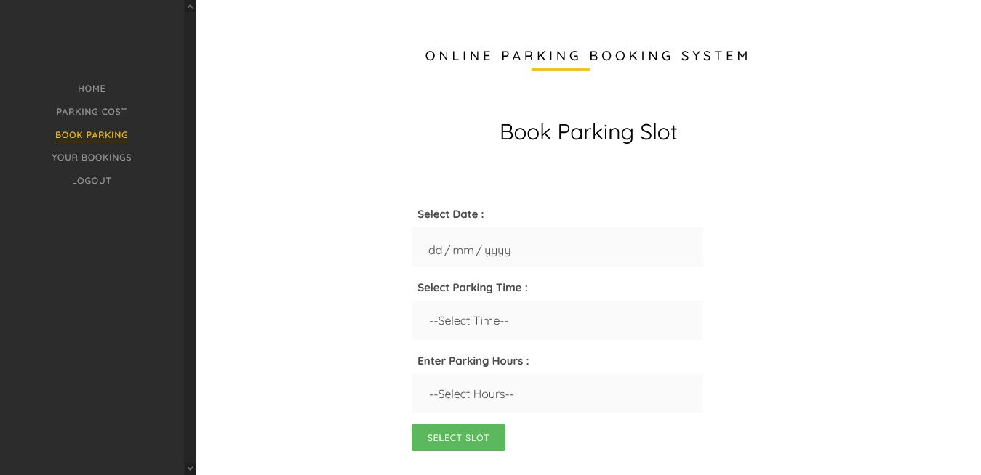

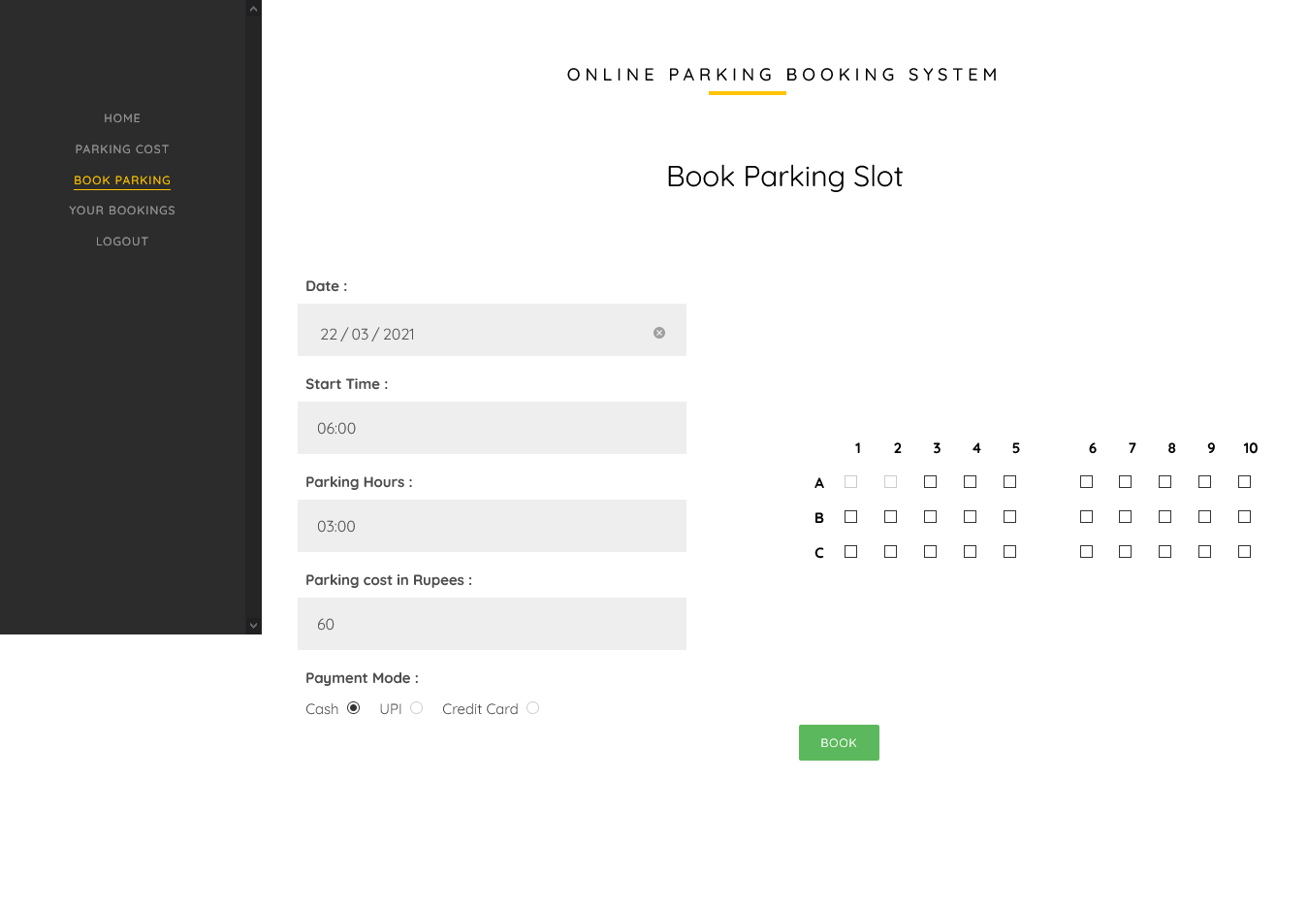

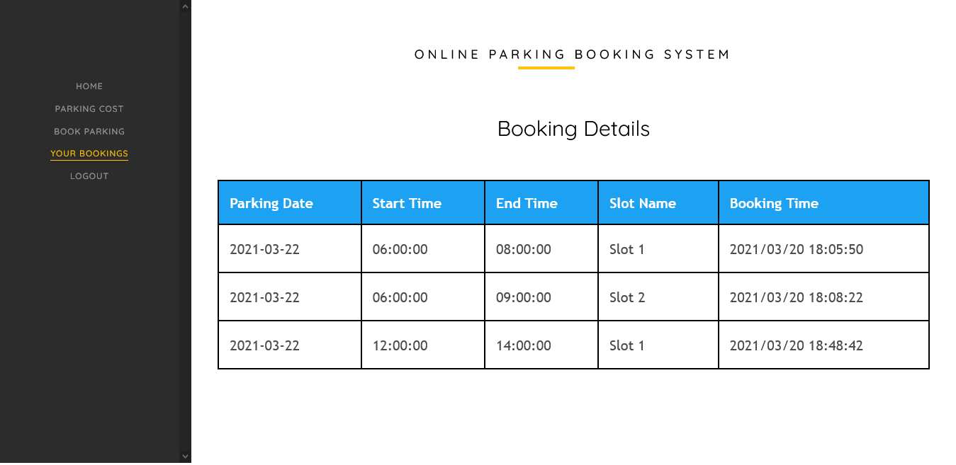

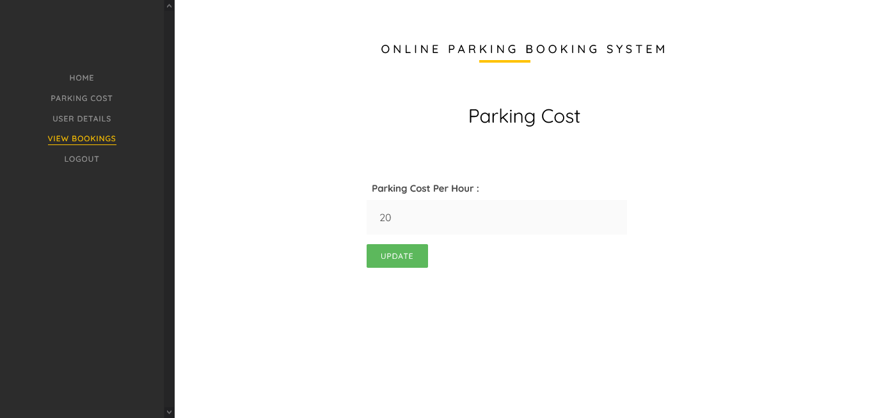

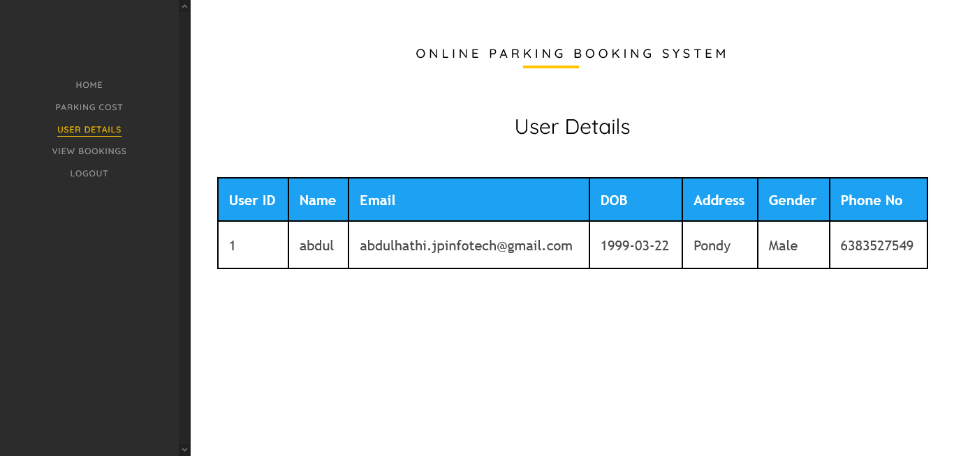

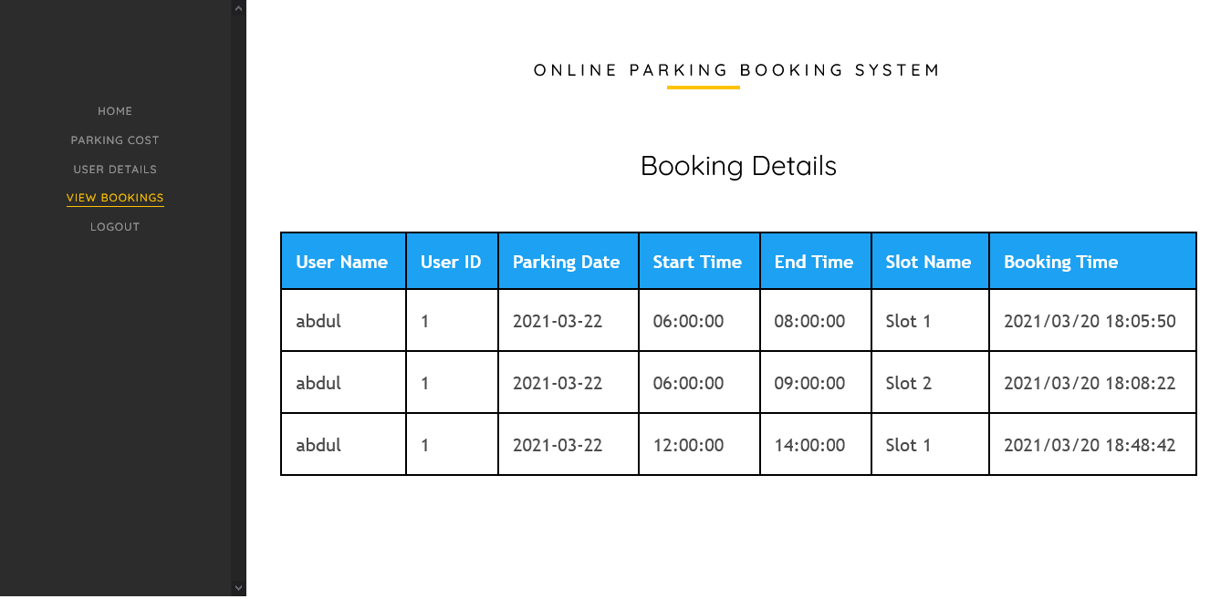

4.4 Quality Assurance

- The Quality Assurance measures followed for the development of Online Parking Booking System are as follows:

- 1. Requirement Validation: Define, record, and validate the requirements for the project in detail. Make sure the system design adheres to the given specifications.
- Testing and Verification:Develop and run thorough test scenarios. Test for compatibility, security, performance, and user interface issues. Record test findings and take care of any problems found.
- Code Review and Compliance:Conduct code reviews to make sure coding standards are being followed. Verify that the code is clear and organised.Ensure that all security and regulatory requirements are met.
- Documentation and Reporting:Examine and confirm the project documents. Create summaries of testing activities and outcomes in reports
- Continuous Improvement: Gather and respond to stakeholder and user input. Software quality should be evaluated and improved continuously. Implement procedure upgrades.
- Compliance with Standards and Best Practices:Ensure adherence to industry best practises and standards.Verify adherence to all applicable laws and regulations.
- Training and Skill Development:Offer assistance with and training for quality control procedures. Encourage a quality-oriented culture among the team.
- Risk Management: Identify and evaluate the quality-related project risks. Create mitigating measures and backup plans.

The Online Parking Booking System can produce a high-quality solution that satisfies user demands, conforms with standards, and ensures a dependable and effective parking experience by adhering to these Quality Assurance procedures.

School of Computer Engineering, KIIT, BBSR 14

Online Car Parking Booking System

Chapter 5

Standards Adopted

5.1 Design Standards
In all the engineering streams, there are predefined design standards are present such as IEEE, ISO etc. List all the recommended practices for project design. In software the UML diagrams or database design standards also can be followed.

The design standards and recommended practices followed for online parking booking system developed using Java and MySQL include:
- User-centric design with a clean and intuitive interface, responsiveness, and effective error handling.
- System architecture and design principles like modularity, secure authentication, and optimization techniques.
- Database design standards such as normalization, efficient data types, validation, and backups.
- Effective use of UML diagrams for modeling and communication.
- Security measures including secure coding, encryption, user roles, and regular updates.
- Thorough testing and quality assurance processes, including automation and security testing.
- Compliance with legal and regulatory requirements.
- Agile project management practices, collaboration, and version control.

By following these standards and practices, you can create a robust and user-friendly online parking booking system that ensures scalability, security, and compliance while providing an optimal experience for users and administrators.

5.2 Coding Standards

- Here are some coding standards follow for the development of Online Parking Booking System:

- Consistency: Keep your code style constant across the whole project. Indentation, formatting, and naming guidelines must be uniformly applied to all code files.

- Naming Conventions: Give variables, functions, classes, and other identifiers meaningful and illustrative names. For naming, use camel case (for instance, myVariable) or underscores (for instance, my_variable).

- Modularity: Create reusable, modular components for the code. Each module or function should only be responsible for carrying out one particular task.

- Comments: Clearly and succinctly describe the intent, functionality, and logic of complicated code portions in the comments. To improve code readability, comments should be used rarely yet effectively.

- Error Handling: To handle exceptions, errors, and edge situations, implement the proper error handling techniques. Use informative error messages and give precise troubleshooting guidance.

- Code Formatting: Use consistent line breaks, space, and indentation to make your code easier to understand. Format code snippets, loops, conditions, and function declarations correctly.

- Code Reusability: Encourage code reuse by developing functions or modules that may be included into other programme components. Instead than duplicating code, make reusable components.

- Security: To guard against widespread vulnerabilities like SQL injection, cross-site scripting (XSS), and cross-site request forgery (CSRF), use safe coding practises. Use parameterized queries and sanitise inputs while also validating user input.

- Version Control: To keep track of changes, communicate with team members, and preserve a history of code updates, use version control tools like Git. Use the proper branching and merging techniques.

- Testing: To ensure the functionality and calibre of the code, incorporate unit testing and integration testing. To guarantee that the code is valid and to cover a variety of circumstances, create test cases.

Following coding guidelines will aid in maintaining the Online Parking Booking System's code quality, readability, and maintainability.

5.3 Testing Standards

- Unit Testing: Testing individual software components, such as functions or modules, one at a time is known as unit testing. The main goal is to make sure that the fundamental programme logic is working properly and that inputs lead to the desired outputs. Prior to integration, you may find and fix any flaws or problems by thoroughly testing each component. Unit tests ensure thorough coverage of the internal code flow by covering several routes and decision branches inside the code.
- Integration Testing : Following the successful completion of individual unit testing, integration testing is carried out. It focuses on examining how various software components that have been combined interact and work together. A smooth integration of the combined components into a single programme is the main objective. Events are the focus of integration testing, which emphasises the integrated system's overall behaviour and results. It aids in locating any problems or differences that could develop as a result of the interplay of the constituent parts.
- Functional Testing : Functional testing ensures that the system's features and functions operate in accordance with the business and technical requirements, system documentation, and user guides. It seeks to verify the behaviour of the system in response to diverse inputs and to make sure that the desired outcomes are generated. Functional testing includes activities including processing valid input, rejecting incorrect input, using stated functions, and verifying particular application outputs. System operations and interfaces with other systems are also taken into account. Test cases are created using specifications, key functionality, and distinctive circumstances.
- System Testing : System testing determines if the integrated software system as a whole complies with the stated criteria and generates known and predictable results. It emphasises on evaluating the system's performance, functionality, and behaviour in a real-world setting. Process flows, descriptions, and planned integration points serve as the foundation for system testing. Testing the system's behaviour under both normal and stressful circumstances, as well as its interactions with other systems and processes, is the aim.

- White Box Testing : White box testing entails examining the software's core operations, architecture, and language. Testers might target certain regions that are unavailable from a black box perspective since they are familiar with how the programme is built and executed. With this kind of testing, the code's edge cases and boundary conditions can be thoroughly covered. It guarantees that all code paths are adequately tested and helps identify any implementation-related problems.
- Black Box Testing : The core workings of the programme are not known during black box testing. The programme is tested as a closed box with an emphasis on inputs and outputs. This kind of testing is done from the standpoint of the user and is based on the needs or specifications of the system. Without taking into account the system's inner workings, the intention is to validate the behaviour and functioning of the system. Black box testing makes that the software performs as expected and acts in accordance with design specifications.

User acceptability testing is extremely important in ensuring that the system is accepted and is in line with user needs in addition to these testing criteria. End users' active participation in the testing process contributes to the verification that the system satisfies the functional requirements and lives up to their expectations.

You may systematically check and verify the usability, effectiveness, and dependability of your online parking reservation system by adhering to these testing requirements. This meticulous process reduces the possibility of flaws, guarantees a high-quality product, and improves the customer experience as a whole.

School of Computer Engineering, KIIT, BBSR 18

Online Car Parking Booking System

Chapter 6

Conclusion and Future Scope

6.1 Conclusion

Due to the fast population development in the modern world, car traffic has ingrained itself into our daily lives. Additionally, the number of unlicensed vehicles has grown. Thus, in order to prevent unauthorised vehicle parking and traffic, our proposed system aims to ensure proper management of vehicles in public spaces like educational institutions, offices, etc. Viewing parking spots, choosing a place for the needed day and time, paying parking expenses, and other functions are among them. A full web application for effectively making parking administration simpler and easier is the online parking booking system.

6.2 Future Scope

Objective: Develop a fully automated parking system with minimal human involvement, enabling advance reservations and self-parking for vehicles. Enhance safety, efficiency, and user experience.

Key features:
- Reservation System: User-friendly app for advance parking bookings.
- Sensor Integration: Vehicle and parking space sensors for precise and secure parking.
- Vehicle Communication: Seamless communication between vehicles and parking infrastructure.
- Automated Parking Maneuvers: Algorithms for autonomous navigation and parking.
- Real-Time Monitoring: Surveillance cameras and sensors for security.
- Navigation Integration: Integration with popular navigation apps for easy access.
- Payment Integration: Digital payment system within the app.
- User Feedback: Feedback mechanism for continuous improvement.
- Scalability and Modularity: Easily adaptable to various parking configurations.
- Security: Robust measures to protect user data and prevent unauthorized access.

Testing, refinement, and expert collaboration are essential for reliability and widespread adoption.

School of Computer Engineering, KIIT, BBSR 19

Online Car Parking Booking System

References

[1]. Tajudeen Olawale Olasupo, Member, IEEE, Carlos En- rique Otero, Senior Member, IEEE,Luis Daniel Otero, Senior Member, IEEE, Kehinde Olumide Olasupo, Member, IEEE, and Ivica Kostanic “Path Loss Models for Low-Power, Low- Data RateSensor Nodes for Smart Car Parking Systems” in IEEE Journals

[2]. Ma. Janice J. Gumasing and Charles Aaron V. Atienza “Parking System for Shopping Centers in Metro Manila” IEEE journals

[3]. Dharmini Kanteti,D V S Srikar,T K Ramesh, “Intelligent Parking System” in IEEE journals

[4]. Julien Nyambal and Richard Klein, “Automated Parking Space Detection Using Convolutional Neural Networks” in IEEE journals

[5]. Pampa Sadhukhan, “An IoT-based E-Parking System for Smart Cities” in IEEE journals

[6]. Wael Alsafery, Badraddin Alturki, Stephan Reiff- Marganiec and Kamal Jambi, “Smart Car Parking System Solution for the Internet of Things in Smart Cities” in IEEE journals

[7]. Archika Singh,Mumin Sajad Shawl ,Shikha Bathla, Nidhi Gaur ,Anupama Mehra, “RFID AND HDL BASED PRE-PAID CAR PARKING SYSTEM” in IEEE journals

[8]. Cheng Huang, Student Member, IEEE, Rongxing Lu, Senior Member, IEEE, Xiaodong Lin, Fellow, IEEE,and Xuemin (Sherman) Shen, Fellow, IEEE, “Secure Automated Valet Parking” in IEEE journals

[9]. Ishraq Haider Chowdhury, Afsana Abida,Md. Mehedi Hasan Muaz, “Automated Vehicle Parking System And Unau- thorized Parking Detector” in IEEE journals

- Emmanouil Chaniotakis, Adam J. Pel, ”Drivers’ park- ing location choice under uncertain parking availability and search times” in IEEE journals

[11]. NHK K. ISMAIL*,”Estimation Of Reliability Of D Flip-Flops Using Mc Analysis”, Journal of VLSI Circuits And Systems 1 (01), 10-12,2019

[12]. Mv Ngo Tien HoA,High Speed And Reliable Double Edge Triggered D- Flip-Flop For Memory Applications”,Journal of VLSI Circuits And Systems, 1 (01), 13-17,2019

School of Computer Engineering, KIIT, BBSR 20

Online Car Parking Booking System

Online Car Parking Booking System

Aniket Kumar Mishra
2029187

- Individual contribution and findings:I took on the database implementation, which included setting up the MySQL database, creating tables, and creating associations. In order to guarantee data integrity and maximise storage, I also applied normalisation techniques to the database architecture. These efforts made sure that the database structure for the online parking reservation system was efficient and effective.

- Individual contribution to project report preparation: My contributions to the report included ensuring that the standards section adhered to industry best practises. This included creating coding and design guidelines that encourage the best possible code organisation, naming patterns, commenting, and documentation. Optimising code performance and maintainability was prioritised. In the system design and architecture section, I also made a contribution that described the general organisation of the system, including component identification, interaction, and data flow.



Full Signature of Supervisor: Full signature of the student:
……………………………. ……………………………..

Online Car Parking Booking System

Ujjwal Singh
2029193

- Individual contribution and findings: I actively participated in gathering requirements, which included learning about the objectives of the project and getting feedback from stakeholders. Additionally, I worked on the system's back-end development using the Java programming language, which led to the creation of a reliable and effective server-side logic for the online parking reservation system.

- Individual contribution to project report preparation: My involvement in the study included helping to develop the software requirements specification (SRS) and resolving the report's issue statement. Through the articulation of the existing challenges and their identification, the project scope was clearly understood. The SRS document provided the development team with a well-organized and documented project by outlining features like Slot Booking, Time-Specific Slot Management, and Slot Availability for the website. In order to gain a solid knowledge of the project's core concepts, relevant research materials were also carefully evaluated to discover approaches and instruments utilised in similar studies. These contributions were extremely important in determining the project's strategy and results.



Full Signature of Supervisor: Full signature of the student:
……………………………. ……………………………..

Online Car Parking Booking System

Abdul Wahid Aadil
2029194

- Individual contribution and findings:I used the Java programming language to complete the back-end development process, which included creating the server-side logic. To manage user requests and process data, the required business logic and algorithms were put into place. I also worked on the system's database design, using normalisation techniques to guarantee data integrity and get rid of duplication. Effective data storage and retrieval were accomplished by effectively organising the database tables and creating relevant linkages. A reliable and effective online auto parking booking system was produced as a consequence of the contributions made throughout the back-end development and database design phases.

- Individual contribution to project report preparation: I provided a lot of contributions to the report's introduction and fundamental concepts parts. The importance of the initiative was emphasised, and the opening provided a summary of the report. The methodologies and tools employed in related studies were identified for the section on fundamental ideas after a thorough examination of pertinent research materials. My contributions helped the project's approach and results, laying a solid groundwork for the investigation.



Full Signature of Supervisor: Full signature of the student:
……………………………. ……………………………..

Online Car Parking Booking System

Ankit Dev
2029195

- Individual contribution and findings: I created the user interface, database schema, and system architecture during the system design phase. The user interface design was made to be simple and easy to use. The database's organisational and functional goals guided its design. The overall system design was established to guarantee efficient operation and component integration. In order to develop an aesthetically pleasing and responsive design, CSS and HTML were also used to construct the user interface. The functioning and look of the online parking reservation system were greatly influenced by these contributions.

- Individual contribution to project report preparation:I gave input to the report's methodology/proposal, outcome analysis, and quality parts. The methodology/proposal part provided a clear idea of the project's completion by outlining the steps and procedures required to develop various website components. The aspect of quality assurance was also covered, making sure that procedures were followed during the planning and execution of the project. A visual picture was given by including screenshots of several website sections.



Full Signature of Supervisor: Full signature of the student:
……………………………. ……………………………..

School of Computer Engineering, KIIT, BBSR 24

TURNITIN PLAGIARISM REPORT
(This report is mandatory for all the projects and plagiarism
must be below 25%)

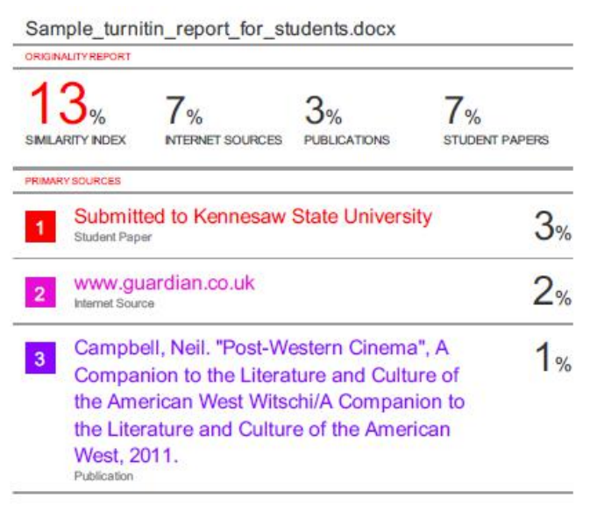

School of Computer Engineering, KIIT, BBSR 25

